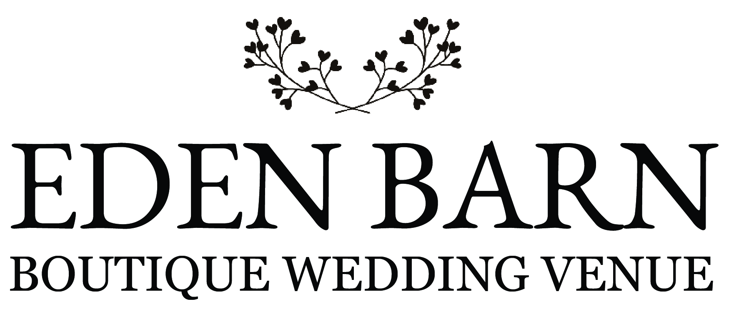

PRIVACY POLICY

Eden Barn is committed to protecting your privacy and this policy explains our practices regarding the Personal Data we collect from our customers, guests and users of our services.
Please read the following carefully to understand our views and practices regarding your personal data. By visiting www.edenbarn.co.uk you are consenting to the practices described in this policy.
Eden Barn is registered in England and Wales under company number 10899739 and our registered office is Swaledale House, Little Musgrave, Kirkby Stephen, Cumbria, CA17 4PQ.
If you would like to contact us for any reason, please email us at edenweddingbarn@gmail.com.
1. The information we collect
Eden Barn collects Personal Data and Anonymous Data from you when you visit our site or when you contact us. “Personal Data” means data that allows someone to identify you, including, for example, your name, address, telephone number, e-mail address, as well as any information about you that is associated with or could be linked to any of the foregoing data. At Eden Barn we need to process personal data so that we can run our business efficiently and provide our customers with the best possible service. To fulfil our role and to run our business we need to enter into a contract with our customers and for this reason and according to the rules of the GDPR we have decided that the most appropriate lawful basis for processing data is 'Contractual'. “Anonymous Data” means data that is not associated with or linked to your Personal Data. Anonymous Data does not permit the identification of individual persons. We collect Personal Data and Anonymous Data, as described below.

2. How we collect Personal Data
- Contact Information
You might provide us with your contact information, for example name, email address or telephone number, whether through use of our services, a form on our website or an interaction with our team. If you, as a visitor to Eden Barn, elect to register or make an enquiry through our website we will collect your first and last names, phone number and email address.
- Usage information
We collect usage information about you whenever you interact with our websites and services. This includes what you click on, when you perform those actions and so on.
- Billing information
If you make a payment to Eden Barn, we require you to provide your billing details, a name, address and financial information corresponding to your selected method of payment.
- Information from third parties
We collect your personal information or data from third parties if you give permission to those third parties to share your information with us or where you have made that information publicly available online. An example of this might be when you provide your personal data to websites that we advertise with.
- Social Media
Should you choose to interact with our social media platforms, we will collect personal data relevant to that platform for example your username, handle or your profile picture and any information that you have chosen to make public on our social media accounts.

3. How we use the information we collect
Eden Barn uses your Personal Data to provide you with a tailored experience at the barn and to provide our services to you and your event. Such services include the preparations leading up to and including your event and the communications that these preparations require. Generally, the communication will be via email, phone or meetings in person. We also use Personal Data to inform you about any updates to our services or the venue and to respond to your requests.

4. Sharing your Personal Data
We will share your Personal Data with third party suppliers who need to process your data in order to interact with us and yourself during the planning processes for your event. These suppliers may be caterers, florists, photographers and so on. These third parties are required not to use your Personal Data other than to provide the services requested by Eden Barn and to guarantee that they have sufficient processes in place to ensure the security of your data whilst it is in their care. When you give Eden Barn consent to plan an event on your behalf we will require you to express your consent to the sharing of your Personal Data with our contractors and the desired third parties. Except as otherwise stated in this Privacy Policy, where you give us your consent, we do not sell, trade, or rent the Personal Data collected from our services to third parties.
If you send a review to us, or post it on another platform or site, we may post it on to our site or use it in our advertising and social media materials. We will attribute your testimonial to you by posting your name next to your comment and any copyright material, if provided.
If another company acquires our company or our assets, that company will possess the Personal Data collected by it and us and will assume the rights and obligations regarding your Personal Data as described in this Privacy Policy and the terms under which you submitted your data.

5. Keeping your data up to date and opting out
Please note that at all times you are responsible for updating your Personal Data to provide us with your most current e-mail and postal address. We will consider it your responsibility to keep your Personal Data up to date so that we do not send any communications via emails or postal address that are not valid. Please note that this Privacy Policy may affect our use of Personal Data that you have provided to us prior to our notifications to you of the changes and, if you do not wish to permit changes in our use of your Personal Data, you must notify us by emailing edenweddingbarn@gmail.com.
Note that we may retain changed or deleted information in our archives, but we will not keep it longer than is necessary.

6. Other websites
Other websites that Eden Barn may advertise on or be featured on may collect your Personal Data but the collection of your data on these sites are the responsibility of the site and not Eden Barn. This Privacy Policy applies only to the use and disclosure of Personal Data that we collect while you use our services.

7. Social commerce and other third parties
We work with trusted third parties, including the social network sites Facebook, Instagram, Twitter and Pinterest. All of these companies operate Third Party Sites. We may provide access to our Sites by third parties, venue-related suppliers and business partners so we can generate interest in our products and services among members of your social networks and to allow you to share product and service interests with friends in your network. We cannot control how your data is collected, stored, used or shared by Third Party Sites or to whom it is disclosed. Eden Barn is not responsible for how these third parties may use information collected from or about you.

8. Processing and storing your Personal Data
Eden Barn is committed to protecting the security of your Personal Data. We use a variety of industry-standard security technologies and procedures to help protect your Personal Data from unauthorised access, use, or disclosure.
Even though Eden Barn has taken significant steps to ensure that your Personal Data is not intercepted, accessed, used, or disclosed by unauthorised persons, you should know that Eden Barn cannot eliminate security risks associated with Personal Data.
Our business can be accessed globally via our website, email address and modern-day technology so your Personal Data may be processed both in and outside of your own country. When you submit your details and in whichever country you are situated you agree to the data being transferred to the UK and processed under the terms of the UK Data Protection Act 1998 and the Privacy and Electronic Communications (EC Directive) Regulations 2003 which stem from European Directives 95/46/EC and 2002/58/EC respectively. If you are not in agreement please do not give us your personal details.

9. Access to your Personal Data
The Act gives you the right to access information held about you. Your right of access can be exercised in accordance with the Act. Any access request may be subject to a fee of £10 to meet our costs in providing you with details of the information we hold about you. We are also legally obliged to request you to provide us with identification so that we can be certain that you are entitled to receive the requested data.

10. Services Eden Barn Uses
Eden Barn uses Google analytics to track how you are using our website and looks at your browsing behaviour, journey and device or browser used. No personally identifiable information is collected via Google analytics. This information is used to help improve the experience for the users.

11. Cookies
Our website uses cookies to distinguish you from other users of our website. This helps us to provide you with a good experience when you browse our website and also allows us to improve our site.

12. Changes to this Privacy Policy
We may amend this Privacy Policy from time to time. If we make material changes in the way we collect, use, and/or share your Personal Data, we may notify you by sending you an e-mail to the last e-mail address you provided to us, by writing to your last known postal address and/or by prominently posting notice of the changes on our website. Any material changes to this Privacy Policy will be effective one month / 30 days following our posting of the notice of the changes on our sites.
These changes will be effective immediately for new users of our services.
- The information provided by you to us during your use of the services, or otherwise when using the website will be held by us on our servers and computers and used by us to review, develop and improve the website and on-line services and to enable us to provide you with relevant information as requested by you.
- Due to the nature of the Internet, the information and data provided by you may be transferred outside the country where it is submitted to us. If you are submitting such information or data from a country within the European Economic Area ("EEA") it is possible that it will be transferred outside the EEA.
- We will not hold such information or data for any longer than is necessary for the purposes set out in this policy statement.
- The website may include hyperlinks to other websites. Your use of such hyperlinks is subject to this policy statement. If you use the hyperlinks then you will be leaving the website. Your access and use of other websites will not be governed by this policy statement and it is your responsibility to check the other websites and the privacy policies that may govern those sites to ascertain how your information and data will be treated if you access and use them.
- You have the right to request access to and/or the correction or deletion of any personal information about you held by us.
- If you have any questions concerning this Data Protection and Privacy Policy please contact us at edenweddingbarn@gmail.com.
- By accepting this policy statement you consent to the use (including processing and storage), transfer and disclosure of your information and data referred to in this policy statement for the purposes set out in this policy statement.

